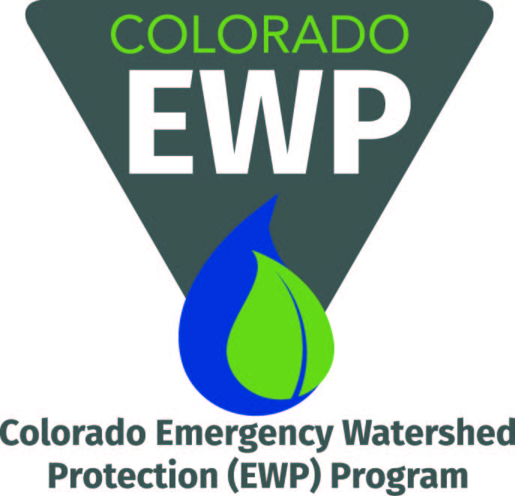
Final Report Template
2013 Flood Recovery

This template outlines the minimum requirements for the final deliverable report required of Colorado Emergency Watershed Protection (EWP) Program grant recipients. Final reports must be submitted to Chris Sturm, chris.sturm@state.co.us, at the Colorado Water Conservation Board (CWCB) with other project close-out materials within 30 days of project completion.
Each final report should contain, at a minimum, all the sections outlined in this template. Additional information and appendices should be included if useful to better understand the project in its entirety. The project’s design report, scope of work and budget, and final construction report are the primary resources needed to help complete the final report.

2013 Flood Recovery
Insert Sponsor’s Organization Logo

Insert Project Name

Watershed Recovery Project
Final Report

Local Project Sponsor:
Project Location: (insert general locale and stream name)
Project Cost: $
Date Project Completed:
Report Prepared by:

INSERT PHOTO(S)
Insert Report Date

Summary
Provide a few sentences summarizing the overall project.

Background
Describe why the project was needed. What events led up to identifying the need for the project? What background resources were used to identify and scope project. These may include existing plans and assessments, such as watershed master plans and damage survey reports.
Include a site summary with general location of the project, as well as locations of the specific sites involved within the project. Describe the approximate area the project covers, e.g. number of square feet or acres.
Provide any information about your organization that is relevant to better understand the project.

Goals & Objectives
Include the bullets for objectives and long-term goals of the project identified by the design team.

Implementation and Benefits
Describe how the project was implemented, including the tasks completed and the project recovery measures installed to achieve the stated objectives
Describe any notable outcomes or accomplishments of the project, such as any measurements taken, materials generated, community and local economic impacts, etc. Examples include the following:
- Number of plants installed
- Number of volunteer hours
- Length of stream recovered
- Length of banks stabilized (right and left)
- Number of structures installed, e.g., root wads, cross vanes, etc.
Use figures, pictures, and tables, if possible, and include captions.
Describe the benefits of the project, including benefits to public safety, natural resources, and watershed resiliency.

Expended Budget
Include the actual expended budget including all cash match and in-kind match funding. Consider using the same format as the budget template provided for the scope of work.

Partnerships
Summarize how partners collaborated and contributed to the project’s successful completion.

Partners
List bullets for the partner organizations contributing cash, in-kind match, volunteers, or other services or materials to the project.

Consultants
List bullets for the consulting firms and contractor(s) that designed and/or built the project.

Maintenance, Monitoring, and Next Steps
Describe the maintenance and monitoring efforts in place and how the project will be evaluated and sustained in the long term. Discuss any future work related to the project. Are there opportunities for follow-up projects to build upon or accelerate this project’s benefits?

Conclusions and Lessons Learned
Discuss whether or not the project objectives were met and to what degree.
What factors contributed to the project’s success?
Discuss difficulties and “lessons learned” with the project. How were these difficulties addressed? Is there anything you would do differently in hindsight?
Why was this project important for your organization and/or the community? Consider including quotes from staff, board members, or landowners.

Primary Project Contact
List the name, organization, email, and phone number of the primary contact for follow-up questions.

Photos
Insert before and after photographs and any other illustrative photos and include captions. Make sure to upload the original image files to the project files in Egnyte.

